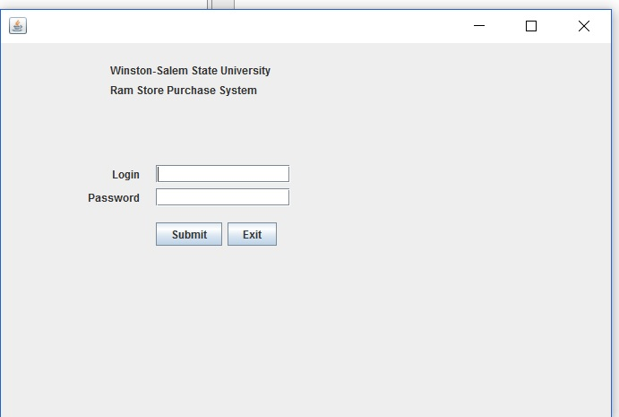

This is the login screen which is used to log into the Ram store. There will be two login levels, User, and Administrator. Which then takes you to the buy in screen.

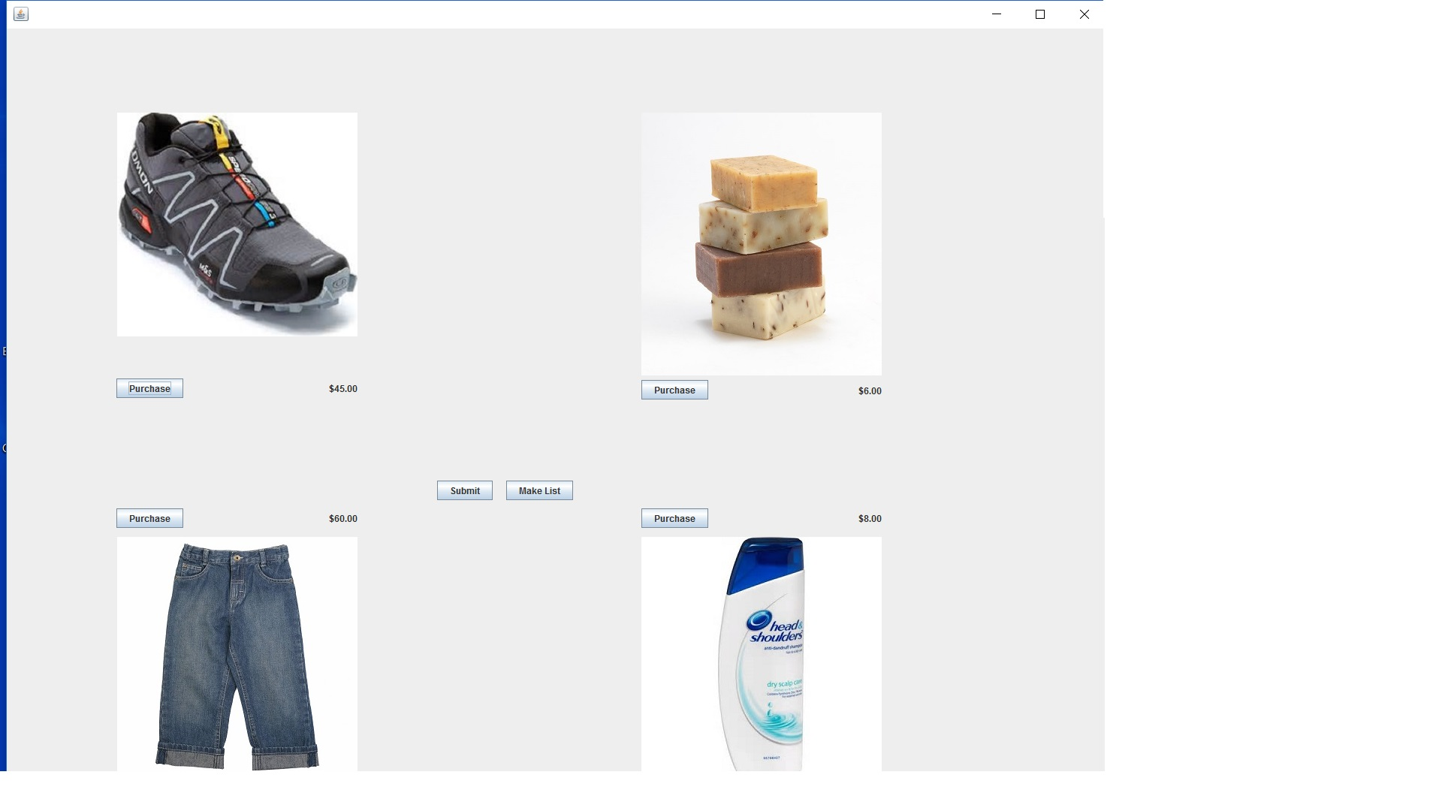

This is the buy-in screen, used to buy goods. There are two buttons on this screen: one, to total the goods out with sales tax, the other to display a list of the goods selected for purchase.

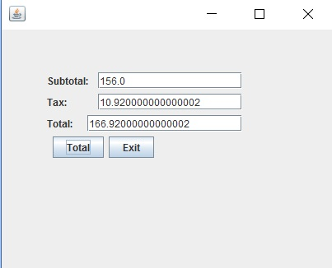

This is the total screen, used to total the goods that have been selected for sale.

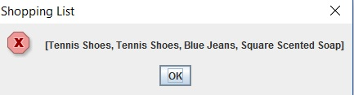

Here is the items list, used to tell what items are being purchased.